Comparison of performance between different models on identification of sparse natural person photos

Meilin Guo, Zi Jin, Sabrina Caldwell

Research School of Computer Science
The Australian National University
Email: u7094624@anu.edu.au
Abstract. This paper is about identification for matching to sparse natural person photos using three kinds of models including simple feed-forward neural network [4], bidirectional neural network [1] and convolutional neural network [3]. It is aiming to identify whether the two images are of the same person given proportions for distances of facial feature marker pairs [2]. I compare the best performances in 20 times for each model with identical settings since the way I partition the unbalanced sparse dataset may cause unstable results. All three of my models lead a superior performance than that in the dataset paper [2], with the order of superior: Feed-forward NN<BDNN<CNN models.
Keywords: Bidirectional neural network, Unbalanced sparse data, Convolutional neural network, Supervised machine learning, Feed-forward neural network
Section I Introduction
Photographs play a significant role in preserving memories and knowledge in a historical way. When a natural disaster strikes, often the first thing survivors mourn are lost photographs. [1] However, countless historical photographs, from decades ago, are orphaned, face images without names, and no living person is able to identify the individual in the photograph even if the photograph is in the public domain, such as the archives of the Australian War Memorial and the National Library of Australia.[1]
The simplest multi-layered Feed-forward neural network [4] is proposed by Svozil to increase the capability of generating more information. It proposed to have multiple layers instead of a single layer to investigate deeper. As the technology advanced, bidirectional neural networks and class prototypes were proposed by Nejad, Akbar and Tamás in 1995, which were based on multi-layer perceptrons trained by a generalized form of the error back-propagation algorithm [4]. These two neural network models are proposed to perform binary classification on photos and identify the individuals in the photos as matching or not matching. The convolutional neural networks give good performance on image processing since it generates 2D inputs and down-samples to preserve the most significant information and establish fully connected layers. It may have better results in identification of persons in photos as well, therefore this model is also used for this identification task.
In this paper, we seek to investigate more on comparisons on performances between three kinds of neural networks, which are Feed-forward neural network (Feed-forward NN), bidirectional neural network (BDNN) and convolutional neural network (CNN).
Section II Method
- Dataset
- Dataset Inspection
There are two kinds of datasets provided along with descriptions corresponding to the paper by Dr Sabrina Caldwell [2]. These relate to a specific category of images: two-dimensional historic still camera photographs of natural persons. Furthermore, we focus more on the case where only sparse photos are contained here. We have 12 sets of 3 images, where Image A & B are identified as matching with the same person but Image C is identified as not matching with Image A nor Image B. Hence, we have 12*3=36 items here where the first item outputs 1 (denotes matching) followed by two items outputting 0 (denotes not matching). [11]
We chose the dataset formulated by proportions for distances between 14 facial feature markers into 91 new features, as shown in Fig. 1 and Fig. 2, instead of choosing the dataset containing only coordinates of 14 facial feature markers because no two photographs to be compared will be the exact same size and aspect. Therefore, it isn’t enough to simply know the distance between points in the image to have useful information to compare against a different image of potentially the same individual. We need to work out the relationships of these distances in comparison to one another in order to compare two different photographs.
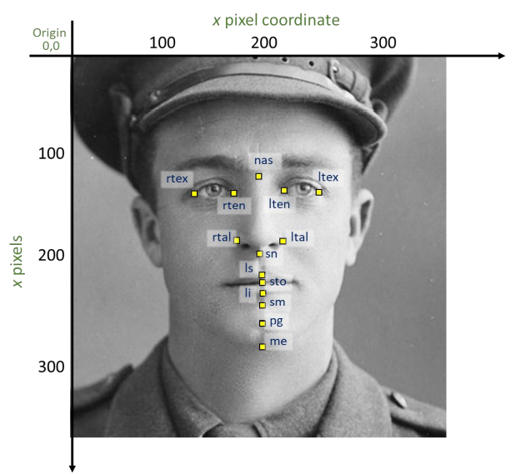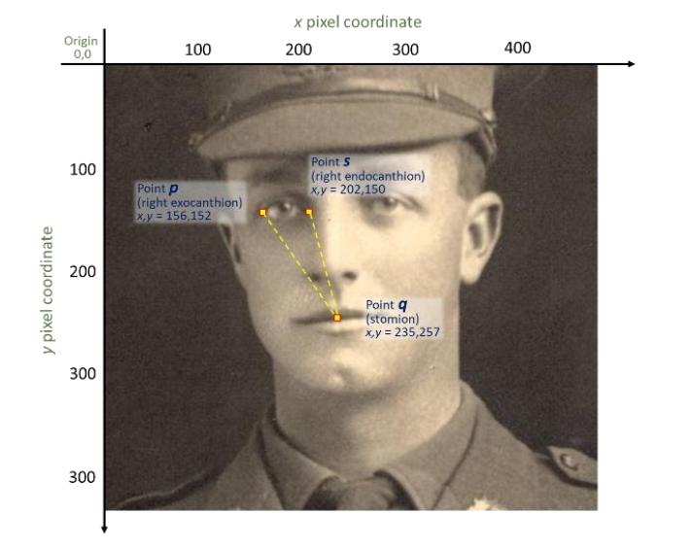
Fig. 1. Set of 14 facial markers depicted [2] Fig. 2. Calculating distance between facial markers in an image [2]

- Dataset Exploration
The type of dataset is basically the float type of all values. It is in the form of Excel with 36 rows and 183 columns (apart from the index column and the feature names’ row) including 91 proportions for distances between 14 facial feature marker pairs diploid due to two images’ information in one line with the identification of matching or not a match denoting the two classes. The data does not need normalization or addition, mergence and pruning on variables, since we will feed the data with the input size of 182 into feed-forward and bidirectional neural network models. As for the convolutional neural network, we generate 182 into 13*14 for each data item to gain 2D inputs, hence no adjustment of the data features are required in this way.
However, an adjustment which is performed corresponding to bidirectional neural network paper is adding an extra node (i.e. an extra feature) [1], which aims to make the associative memories invertible (the same idea of one-to-one function in [1][8]) and increases the generalization and reliability of neural networks. A classical problem, namely XOR problem, and the way of using an output extra node is shown in Table 1, which forms a one-to-one mapping. The reason we abandoned that step is that we successfully realized the reverse process manually by writing a reverse function within BDNN model by multiplying the weights and values inversely. This is realizable mainly due to the fact that the output layer uses a Softmax activation function, instead of binary outputs.
Table 1. XOR problem and using output extra node[1]

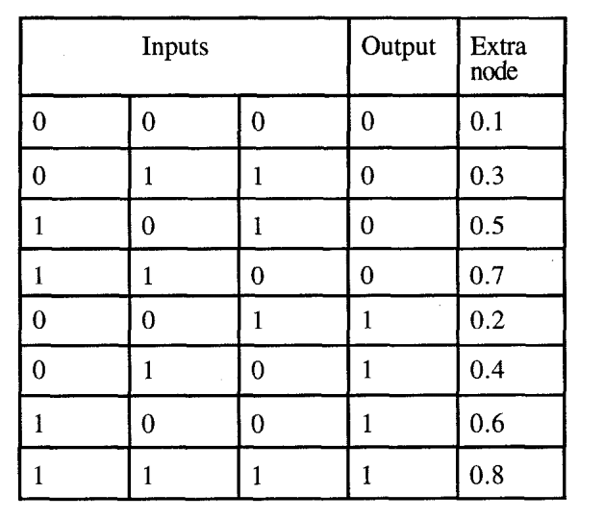
- Dataset Preparation and Findings
The obvious problem we need to tackle first with the dataset is that the proportions for distances between facial feature marker pairs are extremely unbalanced and sparse for the positive class, which is one third of the size of dataset. There exist several methods to ease the limitation and extend the dataset. Ruth G. Shaw and Thomas Mitchell-Olds have proposed ANOVA to analyzing data using analysis of variance [10]. The easiest way to successfully generalize a model is to use more data. The problem is that out-of-the-box classifiers like logistic regression or random forests tend to generalize the model by dropping rare classes. When data conform to a complete, balanced design (equal numbers of observations in each experimental treatment), it is straightforward to conduct an ANOVA, particularly with the aid of the numerous statistical computing packages that are available. However, it is apparent that it is not suitable for classify the binary outputs (positive for 1 and negative for 0) here.
Table 2. Partition on training and test sets
 | Positive class | Negative Class | Sum
Train Set | 8 | 17 | 25
Train Set | 4 | 7 | 11
Sum | 12 | 24 | 36

The technique we used here for the dataset is to manually split the data into train data and test data, as shown above in Table 2. Since we only have 36 items with respect to the 2 classes (positive and negative for matching),we can manually split data to ensure the balance. We try several patterns to evaluate for the optimal, then finalize to randomly split data into 25 out of 36 for training sets and the remaining 11 for test sets. This also makes the datasets disjoint to each other. To ensure the balance and the credibility, we manually set random 4 positive class and 7 negative class for the test set. We shuffle the dataset manually, then select the first 4 positive data and 7 negative data into test, which is capable of achieving randomisation. Note that this is inspired by the method implemented in the dataset paper [2]. However, we make a change on the ratio of test/train sets for 11/25 instead of 12/24, which is mainly for the size of training data to have an integer multiple of the batch size to ensure the capacity of training reversely in the directional neural network model.
We use this method for all models I have implemented. The most significant pitfall with this method is that it also leads the results (such as accuracy) to having a large variance related to diverse partitioning on the dataset. Therefore, we need to alleviate this problem by other means.
- Architecture of Models
There are three kinds of models we have applied to investigate performance, these are feed-forward neural network, bidirectional neural network and convolutional neural network. The basic concepts are discussed as below.
a. Feed-forward Neural Network
A classical Feed-forward neural network is demonstrated below in Fig.3. The model we applied is similar to this sample. The Feed-forward NN gets the fixed size of inputs which are then fully connected to the first hidden layer, through to the following hidden layers, ultimately to an output layer. Weights are the values on relationships between neurons in connected layers while biases are added to neurons. Activation functions are determined to sensitize the layer forward. We could set the estimated cell to Softmax for classification or other approaches like Log and Tanh for regression. The weights are updated corresponding to the optimizer by back propagation.
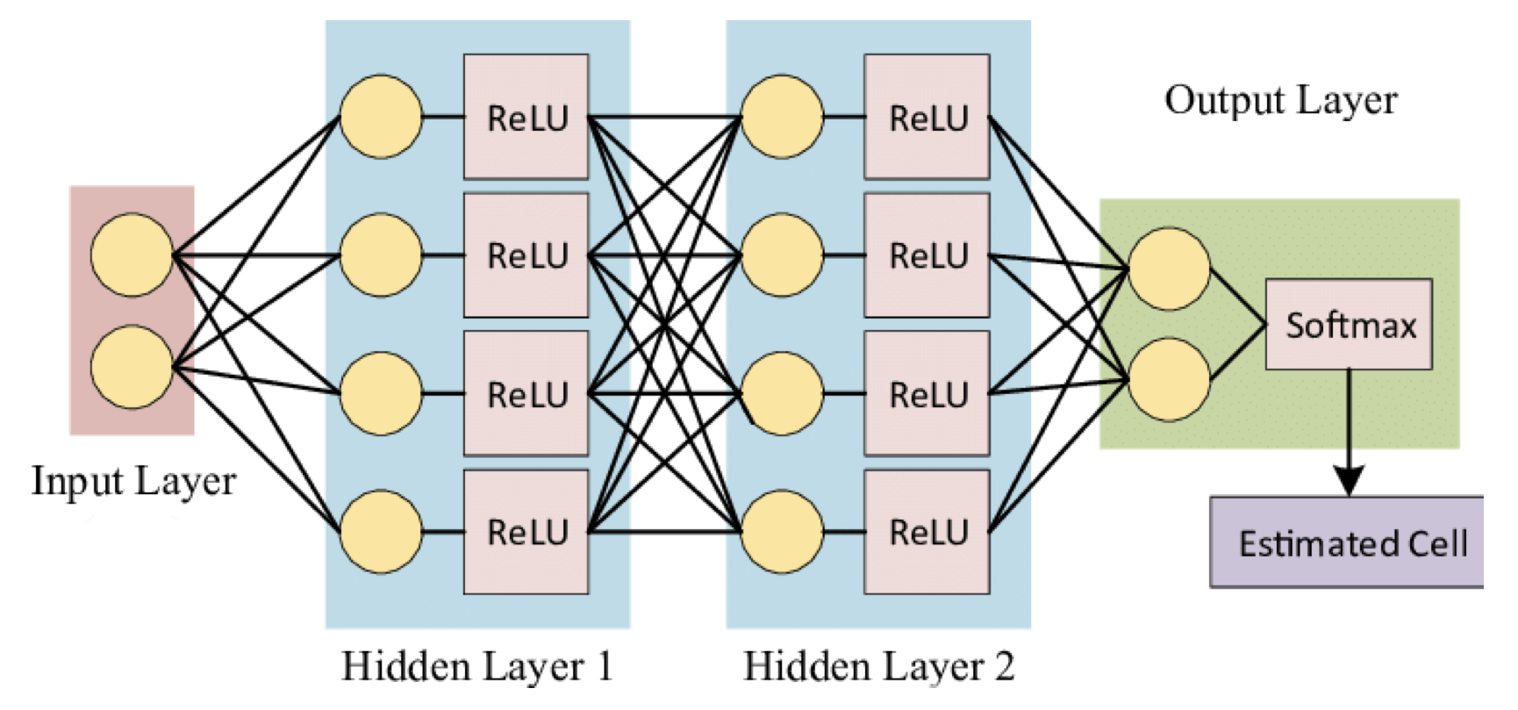
Fig. 3. Sample Topology of Feed-forward NN [7]
b. Bidirectional Neural Network
A bidirectional neural network is slightly superior to the feed-forward neural network, because it takes into account that the output is related not only to previous sequence elements, but also to subsequent sequence elements.
This model has a similar architecture as the feed-forward neural network, but it can be run in both directions: from inputs to outputs and from outputs to inputs, with shared weights and separate bias on the forward and reverse processes, as shown on Fig. 4. As we know that backpropagation is applied to update and optimize weights from output layers, each direction of process on BDNN can have an impact on weights in another direction since they are shared, and in turn have effect on loss and accuracy.
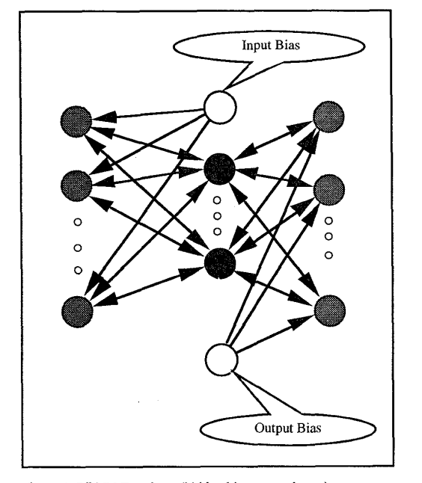
Fig. 4. BDNN Topology[1]
c. Convolutional Neural Network
We can consider a convolutional neural network is more generate since it can have a more comprehensive aspects on inputs, comprising data and the position (not only the front and back sequences like BDNN), because the CNN input is 2D instead of 1D with only a sequence [3]. The classic and most popular example of using CNN networks is image processing.
The sample topology of CNN is shown in Fig. 5. In the sample topology, the input is of shape 23*28, feeding into the first convolution layer to have 20 channels. Then it down-samples into one fourth size, and feeds into the convolution layer and down-samples again. Generally speaking, CNN model will end up with a fully connected layer with specified output size.
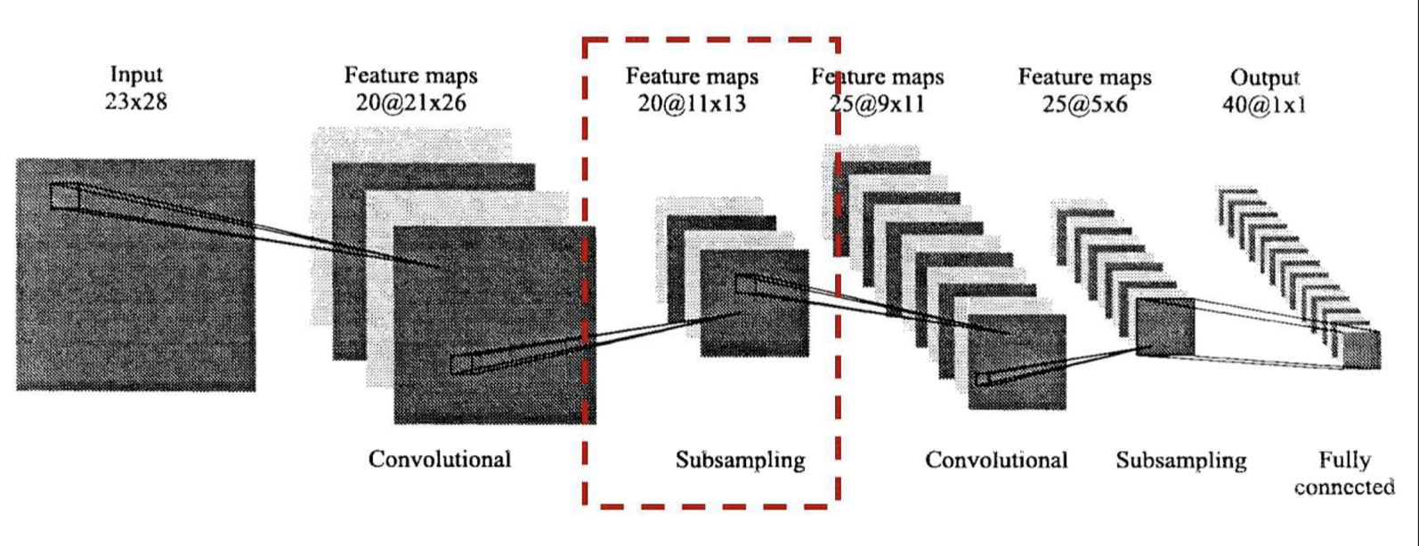
Fig. 5. Sample CNN Topology [5]
C. Evaluation
As for the implementation on both training and testing the bidirectional neural network, the model is designed to process forward then backward with one batch. The loss calculated in bidirectional neural network is the sum of both directions.
We have defined variables to record history with the accuracy and loss change for training and testing for each model. A supervision layer is conducted to ensure a better performance on models.
We evaluate the performance of each model by assessing the best performance during 20 times tried, which is due to the weak robustness of data partitioning on training and testing datasets. Then we fine-tune the hyperparameters to achieve better results. Note that it is possible to improve evaluation, and one of these methods is considered in future work.
Section III Implementation
- Settings and Parameters
After varieties of attempts on parameters, such as loss and accuracy change on both training and testing datasets, we finalize to have the parameters shown in Table 3.
Table 3. Parameters of three models
 | Feed-forward NN |  | BDNN | CNN
Number of Epoches |  | 50 | 50 | 50
Learning Rate |  | 0.02 | 0.02 | 0.02
Loss Function |  | Cross Entropy Loss | Forward:  Cross Entropy Loss  Backward:  MSE | Cross Entropy Loss
Optimizer |  | Adam | Adam | Adam
Batch Size |  | 5 | 5 | 5
Topology |  | Input Layer :1*182  Hidden Layer 1: 30, ReLU  Hidden Layer 2: 10, ReLU  Output Layer: 5 |  | Input size: 13*14  C
Conv2d:1,5,3*3, ReLU
(1,5,kernel_size=3)
 |  |  |  | Conv2d:5,10,5*5, ReLU
 |  |  |  | Maxpooling:2*2,padding=1
 |  |  |  | Fully Connected: Input:40, output:5, Softmax

- Pipeline
- Datasets
We loaded the data to variable data and dropped the first column as it is the identifier. We shuffled the data manually using sample function which is built in pandas package. We used variables data_match and data_not_match to denote positive and negative classes by the value of output column. Then we pre-define some hyperparameters for splitting datasets. It is sufficient for us to have two hyperparameters located the size and distribution of positive and negative data points in training and test sets. The two hyperparameters we define here is the number of positive data in test set and the size of test set, denoted by test_match_num and test_num. As a result, test_match, test_not_match, train_match and train_not_match are calculated by fraction on sample function which is all computer by the two hyperparameters. Therefore, it ensures the feasibility of codes. The positive and negative classes are concatenated separately to formulate training and test datasets, denoted by train and test. The number of features is represented by n_features, which is simply the result of the number of columns in the train set less one. We also split features and output for convenience to calculating loss. Ultimately, train and test tensors are defined to hold inputs and outputs. We load the data to fit into models.
- Training and Testing
Hyperparameters for each model are defined in the first place, which are batch_size, learning_rate ad epochs. History records are defined before training and testing for plots, which are train_loss, test_loss, train_acc and test_acc. The model’s mode is set to train() in advance. The accuracy and loss are reset to zero before each batch. During each batch, we set the optimizer to have zero gradients. Loss is calculated by an inbuilt function in the torch.nn.function package called cross_entropy by feeding in the labels and outputs from models. Note that loss on BDNN model is calculated by the sum of forward and backward. Eventually, we activate loss to back propagate and optimize weights.
The testing process is merely identical to training but obtaining data from test_loader and set the model’s mode in eval() in advance instead.
Section IV Results and Discussions
- Results
The loss and accuracy change on the best settings for the three kinds of models over epochs is shown in Figs. 6-11.
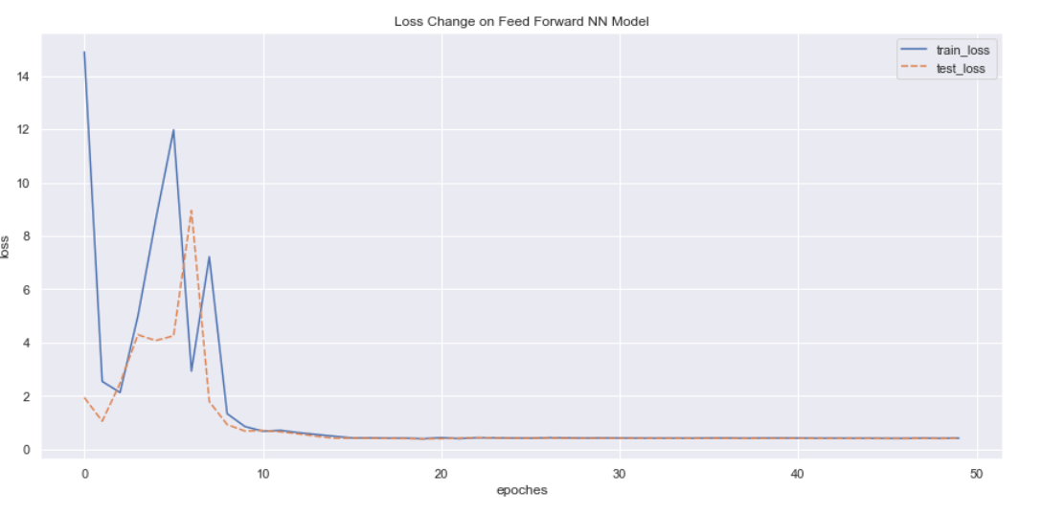
Fig. 6. Loss Change on Feed-Forward NN Model
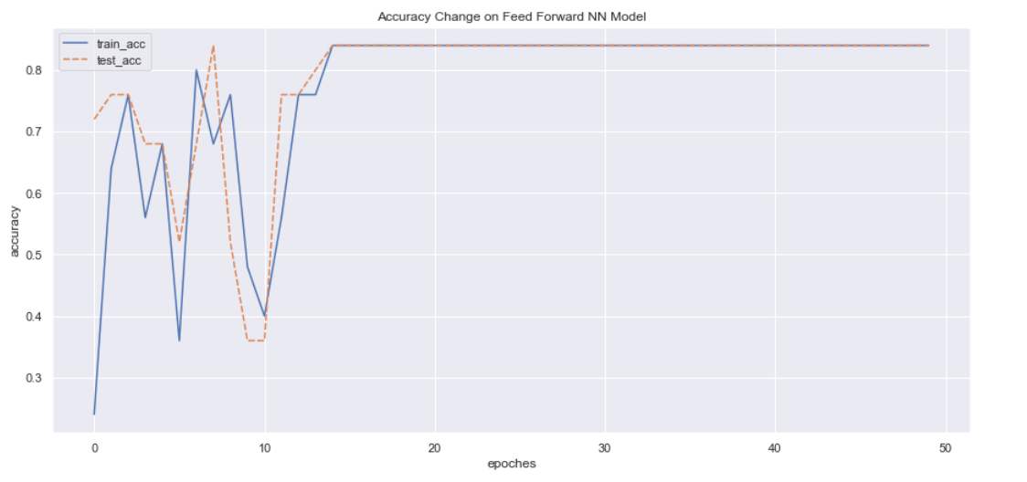
Fig.7. Accuracy Change on Feed-Forward NN Model

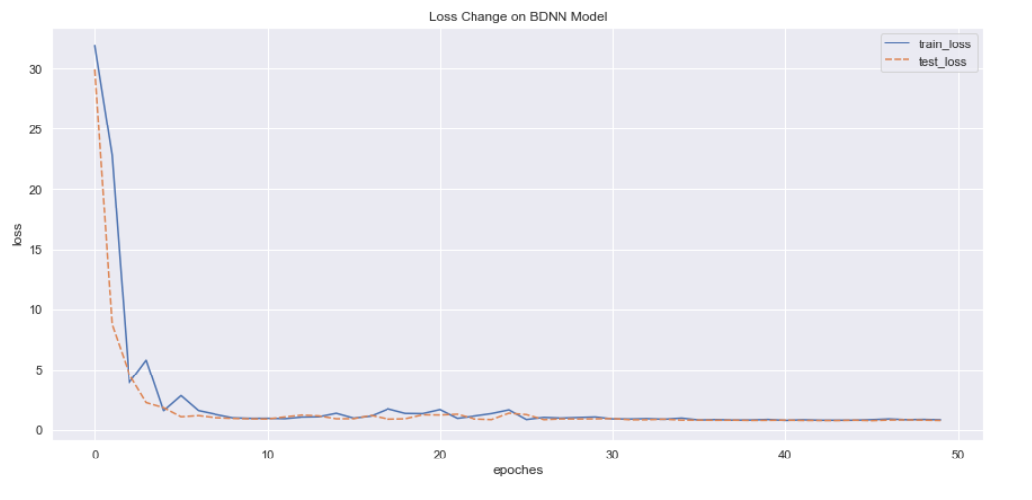
Fig. 8. Loss Change on BDNN Model

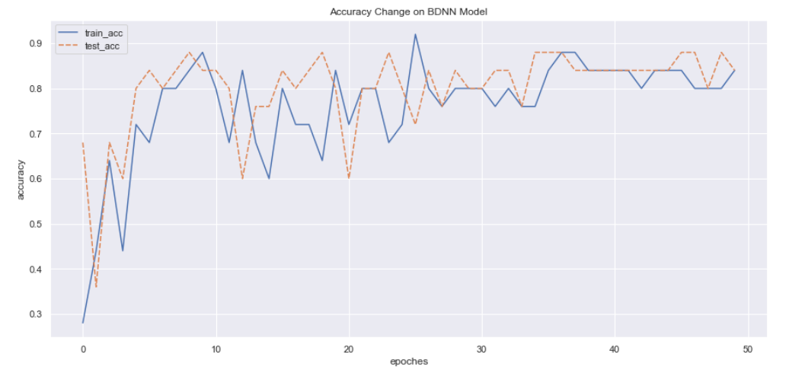
Fig. 9. Accuracy Change on BDNN Model
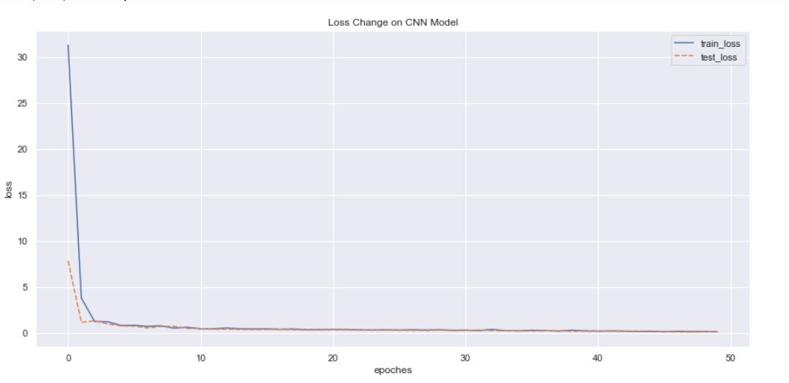
Fig. 10. Loss Change on CNN Model

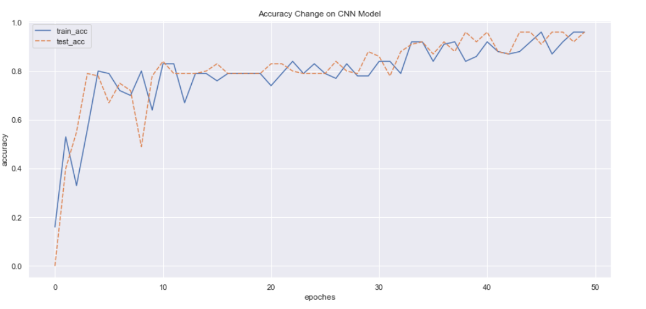

Fig. 11. Accuracy Change on CNN Model

- Discussions
- Performance Comparison on Dataset Paper
The classification neural network in the dataset paper [2] contained 2 hidden layers, with 10-fold cross validation to mitigate the effect of the small dataset size. The training was set to 24 out of 36 feature sets and testing was set to the remaining 11 out of 36 feature sets. The test set was set to 4 ‘match’ and 8 ‘not a match’ [2]. The best accuracy that the model could achieve was 75%, which was the average across 10 iterations of 10-fold classification [2].
As for our accuracy on models, the accuracies on all three models are greater than 80%, with a maximum value of 96% and the minimum of 80%, which suggests superior capability of identification of sparse natural person photos.
- Performance Comparison Between Three Models
Convergence time consumption:
As the results shown above, the Feed-forward NN model finalizes to converge at epoch 13 more quickly, while the BDNN tended to be stable at epoch 35, with a longer time consumption to converge than the Feed-forward NN model since the update on weights with be affected by the reverse direction process on BDNN model, which gives a great possibility to change the optimal weights. Therefore, it requires longer time. However, the result shows within a normal range. The slowest one is CNN model, which is since it may need more time to get information in 2D and have more layers, not only simply fully connected layers.

Accuracy and Loss:
The CNN model performs the best on accuracy of classification on outputs, with a maximum value over 95% and a nearly zero loss. This model is able to obtain more information on natural person photos. Therefore, it is unsurpriseing that it would have the best accuracy.
The accuracy on the BDNN model is the worst among these models, with a minimum value of just over 80%. In the meanwhile, we can see from the accuracy change on BDNN model during the middle part from epoch 10 to epoch 28 that the accuracy tends to fluctuate a lot while the loss doesn’t change much. We believe the reason behind this phenomenon remains the instability caused by shared weights. The loss and accuracy are computed after each batch of back and forth, while the better results may be affected by the reverse direction of process..
The loss for all three models is of an approximate zero value, while Feed-forward NN model may lead a highest loss, but still, lower than 0.5. The accuracy is between BDNN model and CNN model, since it can only obtain 1D information but is free of interruptions backward.
Section V Conclusion and Future Work
The biggest drawback of our model is the lack of a validation system to fine-tune better hyperparameters, and evaluating models, like K-fold Cross Validation [9]. It may lead to improved results to evaluate models just based on accuracy of test sets by multiple attempts. We can address this in future work. We can also consider the optimizer; we have applied Adam for all of three neural network models, while another optimizer, namely AdamW, is well-known to converge faster than other common optimizers like SGD (stochastic gradient descent) [6]. It may lead to better results on a shorter time.
As for the implementation procedure on BDNN, we have successfully implemented this by using the back-and-forth method, which means a batch of data is training and testing for both forward and reverse at one epoch. Meanwhile, the loss is calculated by the sum of both ways. Another procedure can do in the future is implement an alternative method described by Hossain and Gedeon, which is of the process that the model is fully trained on one side with a threshold on loss calculated that way, which will stop with a lower loss by threshold, then switch the direction. It can be designed to stop either by the number of epochs or the threshold on loss like the first half process [9].
In conclusion, all three of my models lead to a superior performance than that in the dataset paper [2], with all accuracies greater than 80%. Moreover, CNN fits the best to classify each pair of photos among them, while BDNN finalizes the worst caused by the backward process. The Feed-forward NN model expresses the average performance.
References
[1] Nejad, Akbar Farhoodi, and Tamás D. Gedeon. "Bidirectional neural networks and class prototypes." Proceedings of ICNN'95-International Conference on Neural Networks”. Vol. 3. IEEE, 1995.
[2] Caldwell, S. (2021) "Human interpretability of AI-mediated comparisons of sparse natural person photos," CSTR-2021-1, School of Computing Technical Report, Australian National University.
[3] Shin, Hoo-Chang, et al. "Deep convolutional neural networks for computer-aided detection: CNN architectures, dataset characteristics and transfer learning." IEEE transactions on medical imaging 35.5 (2016): 1285-1298.
[4] Svozil, Daniel, Vladimir Kvasnicka, and Jiri Pospichal. "Introduction to multi-layer feed-forward neural networks." Chemometrics and intelligent laboratory systems 39.1 (1997): 43-62.
[5] Tom, S1,2021, Lecture notes, DL3-Convolutional Neural Networks, page 38, COMP 4660/8420, Bio-inspired Computing: Application and Interfaces, The Austrian National University, adapted from lecture notes by Christopher Chow ad Josephine Plested.
[6] Loshchilov, Ilya, and Frank Hutter. "Fixing weight decay regularization in adam." (2018).
[7] Belmonte-Hernández, A., Hernández-Peñaloza, G., Gutiérrez, D.M. and Alvarez, F., 2019. SWiBluX:
Multi-sensor deep learning fingerprint for precise real-time indoor tracking. IEEE Sensors Journal,
19(9), pp.3473-3486.
[8] Jacobsen, Jörn-Henrik, Arnold Smeulders, and Edouard Oyallon. "i-revnet: Deep invertible networks." arXiv preprint arXiv:1802.07088 (2018).
[9] Hossain, M.Z. and Gedeon, T., 2017, May. Classifying posed and real smiles from observers&apos;
peripheral physiology. In Proceedings of the 11th EAI International Conference on Pervasive Computing Technologies for Healthcare (pp. 460-463).
[10] Shaw, Ruth G., and Thomas Mitchell-Olds. "ANOVA for unbalanced data: an overview." Ecology 74.6 (1993): 1638-1645.
[11] Meilin Guo, "Bidirectional Neural Network on Identification of Sparse Natural Person Photos" , the 4th ANU Bioinspired Computing Conference.

